# **Angular Environment Setup**

**Setup**

1. Install Angular/Cli
   1. Open command prompt
   2. Type npm install -g @angular/cli
2. Create a new folder in ‘C’ drive with ‘Angular’
3. Open command prompt at Angular and type ng new my-first-app and hit enter
4. Navigate to the my-first-app as mentioned below and type ng serve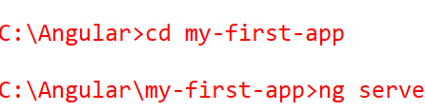
5. Now go to the browser and type <http://localhost:4200> to see our first web app.

**Editing our first application**

1. Install the bootstrap using below command line option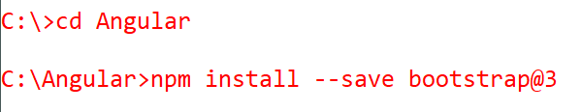
2. Replace the below angular.json file in the ‘C:\Angular\my-first-app’ folder
3. Extract and Replace the src folder inside the ‘C:\Angular\my-first-app’



1. Launch the browser and type <http://localhost:4200> to see the below output

